**12/16/20 Team Wraith Practice Summary**

Practice today consisted of a warmup fleet battle and a two game scrimmage with Tempest.

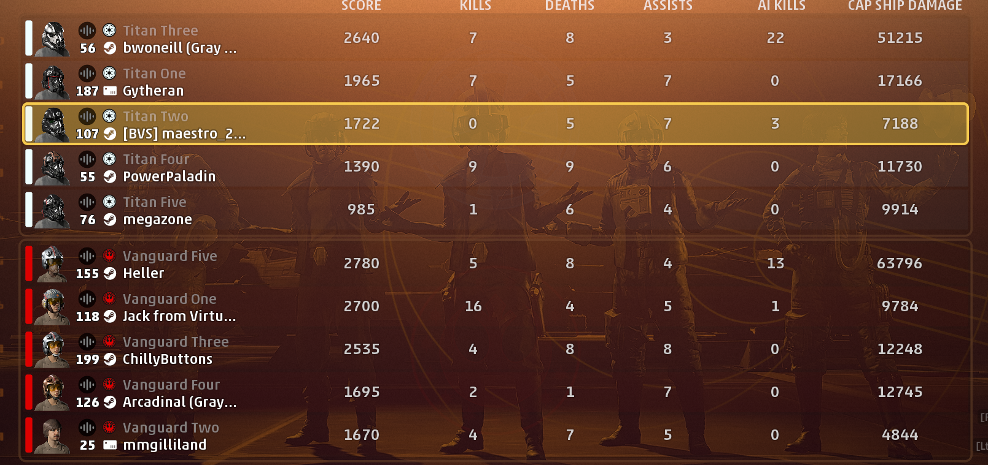

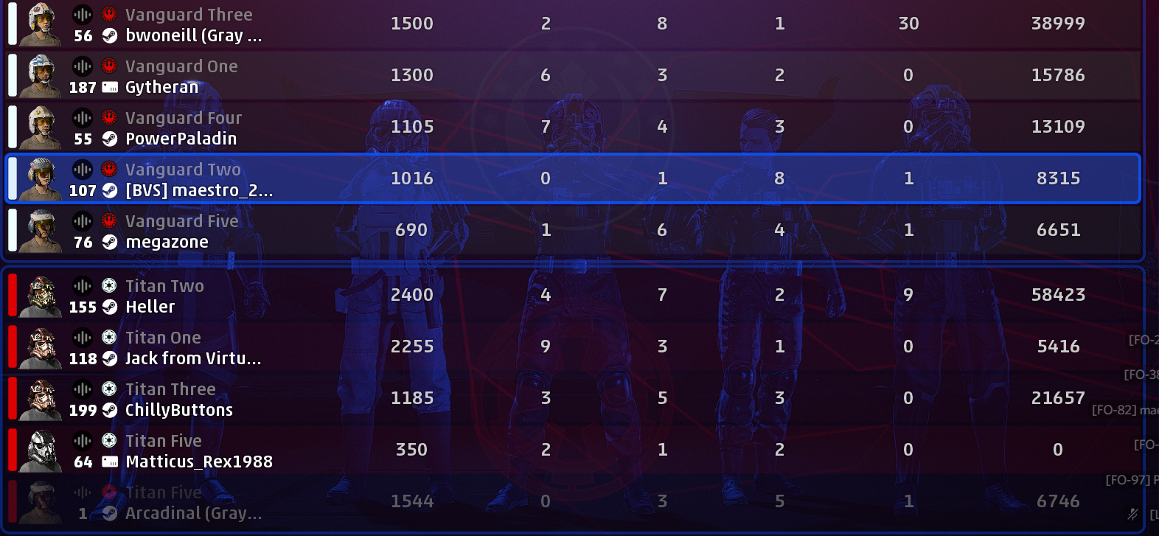

**Psyren’s Notes**

* Attempted corvette rush. Needs more firepower to be effective.
* Bomber should be equipped for both AI and Damage dealing, doing just one job takes away from group.
* Ion Torpedoes are very important. Maybe some dedicated training sessions for that and other key aspects.
* Too many rockets, the overall dps of the team was lacking.
* Lots of players tried shooting very close to max range.
* Everyone was very good at breaking pursuit if the target was too far away. Deaths mostly due to being jumped while away from allies.
* When everyone’s timing was good, the team made TONS of progress. Crazy damage and multiple ships/subsystems down in one phase.

**Tempest Match Debriefing notes**

* Multi lock doesn’t kill xwing AI in one go.
* Multi-lock will can be tricked into hitting one pointblank target.
* Have One payer hang back to guard the shield gens.
* Have a plan to break shields quickly.
* Ion torp raider at beginning of defense, and hit its hull during breaks in the action
* Lots of callouts, especially the nearest threat.
* Many players were separated and easy kills by group fire
* A bulkier ship taking point is good for splitting enemy attention/ pressuring AI farmers

We also arranged into training pairs. It’s a loose experiment to practice communication and battle awareness. Flying in proximity or pulling wombo combos isn’t the primary goal, but its important to know when you are alone and need to pull back vs have plenty of cover and push in. Nobody should be a sitting duck/easy target.

The current training pairs are:

Psyren & Megazone

Gytheran & Maestro

BlackRanger & mikep192

Optimistict & PopeOfToast

PowerPaladin & bwoneill

These pairings were made to balance experience and similar schedules, so pairs can practice outside of Wraith meetings.

If you haven’t already, read the Orientation Guide. It was recently updated to v3.0. Type in “$guide” in any channel to have the droid give you the file.

Ideas for future practice exercises:  
Ion Torpedoes

Defense Strategy

Drifting and the Boost Meter

Attacking Subsystems (both factions)